DCU Update Scholarly Work Repository Item count



FileType: Microsoft Office Excel (2017_faculty_list(Updated).xlsm)

Last Modified Date: 4/7/17

Author: Isaac Samuel Raj Boddu

TABLE OF CONTENTS

Introduction 3

Section 1.1 3

about 3

how to use 3

important info 4

Developer 5

Modify 5

Going Forward 5

Introduction

About:

The excel file lists the faculty as of 2017 working at UNT and their job titles along with their department.

The column SW Contributions holds the total number of Scholarly works contributions each member holds at the UNT Scholarly works digital repository (As given by the repository).

An attempt has been made to automatically update the count using the API supported by the UNT Scholarly Works.

How to use:

* Open the file and click on the ScholarlyWorks tab available.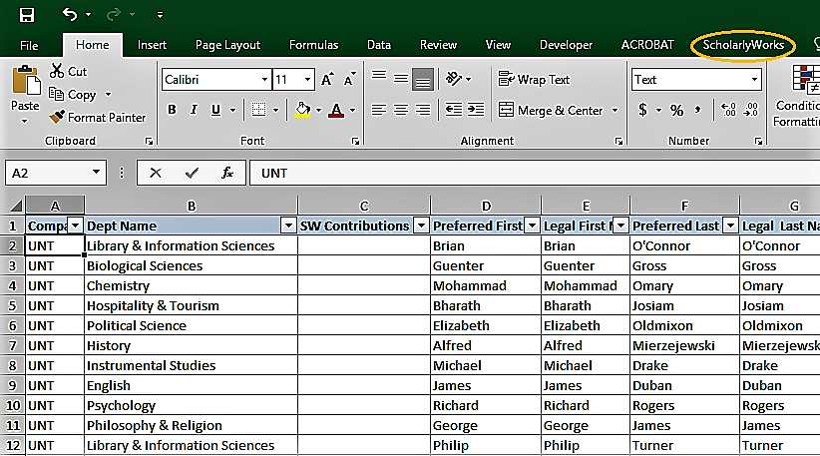
* Click on the Update SWC button under the new tab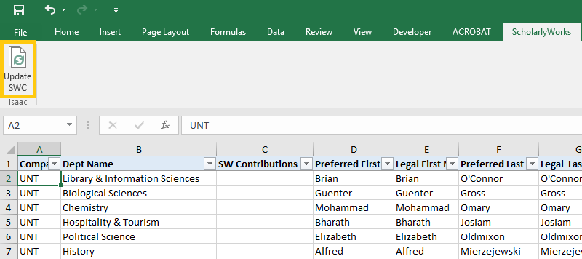
* This should automatically update the required column with values as shown below.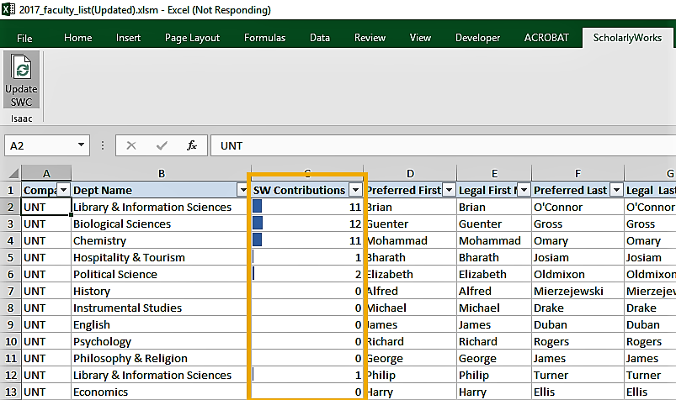

important info:

* Please note that based on the number of records that need to be processed depends the duration of the operation. So it might take a while to complete the process and the file would be unresponsive during that period.
* Please do not modify the order in which the columns appear (as this might lead to unexpected behavior) and if required, contact the creator or refer to the developer section of this document.

Developer

Modify:

* Press Alt+F11 to enter the VB Editor. All code is available here and free to be modified as required.
* The column numbers for Names and ScholarlyWorkCount fields have been manually set and can be modified here to newer values if necessary.
* The ribbon functionality has been introduced and the corresponding code is available under Modules in Project explorer.

*Please test thoroughly before passing the file to users. *

going forward:

* Updates can be made to fetch more details from the API and also integrate from other service providers.
* Graph API could be explored to make numbers look more appealing.